University Of Engineering and Technology, Lahore
Computer Engineering Department

Course Name: Programming Fundamentals | Course Code: CMPE-112L
Assignment Type: Lab Work | Dated: 16-02-2026
Semester: 1st | Session: Spring
Lab/Project/Assignment #: 1 | CLOs to be covered: CLO1
Lab Title: Input/Output, Conditional Statements | Teacher Name: Hafiz Muhammad Mubashar
Lab Evaluation:

CLO1 | Apply appropriate programming techniques to create executable programs to solve well defined problems
 | Level1 | Level2 | Level3 | Level4 | Level5 | Level6
(5)
Total |  |  |  |  |  | /5
Rubrics for Current Lab Evaluation
Scale | Marks | Level | Rubric
Excellent | 5 | L1 | Submitted all lab tasks, BONUS task, have good understanding.
Very Good | 4 | L2 | Submitted the lab tasks but have good understanding
Good | 3 | L3 | Submitted the lab tasks but have weak understanding.
Basic | 2 | L4 | Submitted the lab tasks but have no understanding.
Barely Acceptable | 1 | L5 | Submitted only one lab task.
Not Acceptable | 0 | L6 | Did not attempt
LAB No 1
Lab Goals/Objectives:
The goal of this lab is to understand and use Python decision-making statements. We learned how if, if-else, elif, nested if, logical operators, and conditional expressions work. These programs help solve simple real-life problems. The lab also improves basic programming and problem-solving skills.

Equipment Required:
Computer or Laptop, Py Charm, Vscode

Theory:
Python uses conditional statements to make decisions based on different conditions. The 'if' statement checks a condition, 'else' runs when the condition is false, and 'elif' checks another condition. Logical operators like and, or, and not combine conditions. These statements are useful for building interactive programs.

Lab Work:

Task 1:Used a simple if statement to check whether a person is an adult based on age.

Result:

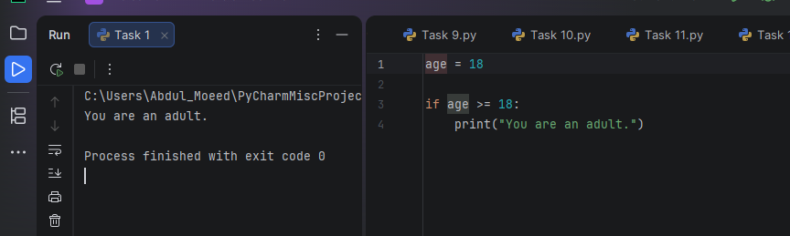

Task 2:Used if-else to check whether a number is even or odd.

Result:

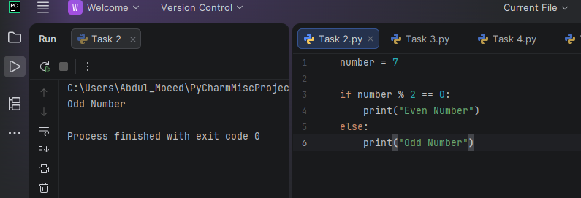

Task 3:Used if-elif-else to assign grades according to marks.

Result:
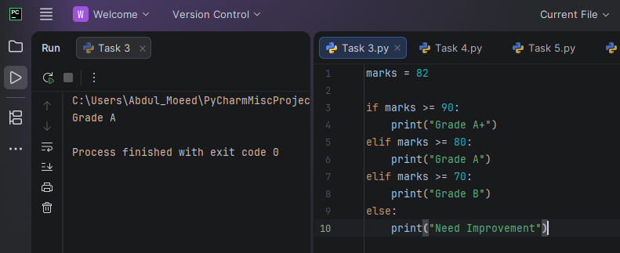

Task 4: Used nested if to allow entry only when age and ID conditions are met.

Result:
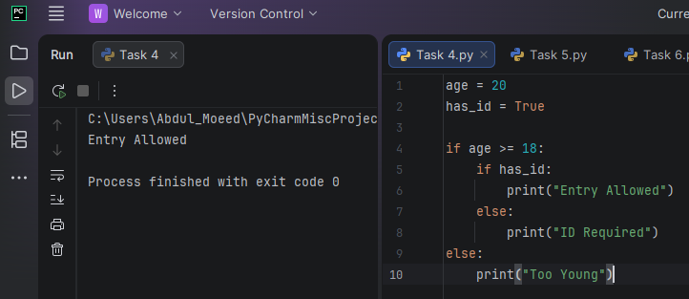

Task 5: Used logical AND to verify username and password.

Result:

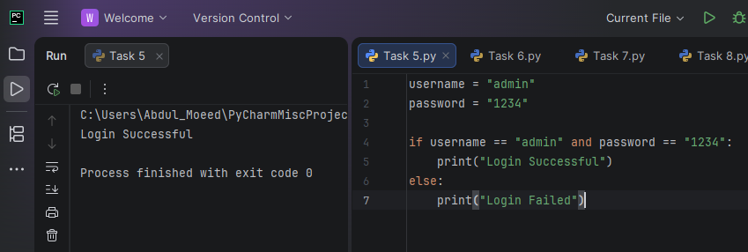

Task 6: Used logical OR to identify weekend or weekday.

Result:
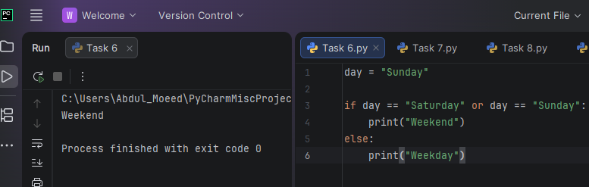

Task 7: Used NOT operator to check login status.

Result:
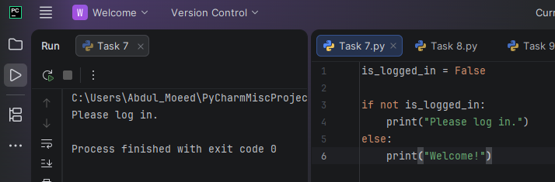

Task 8: Used multiple conditions to classify temperature.

Result:
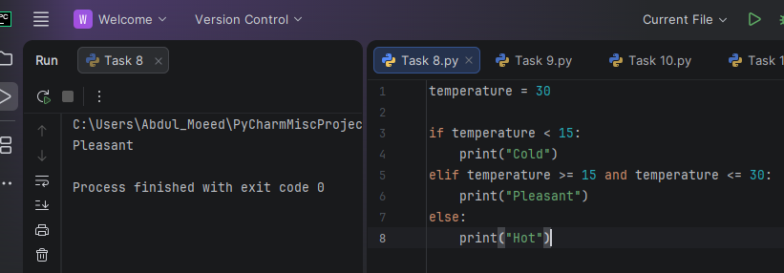

Task 9: Used Python conditional expression (ternary operator) to print Adult or Minor.

Result:
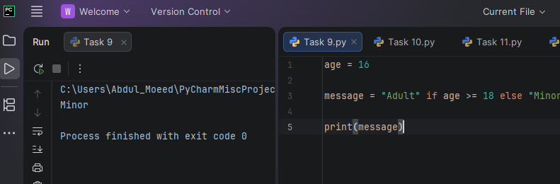

Task 10: Checked whether a fruit exists in a list using membership operator.

Result:
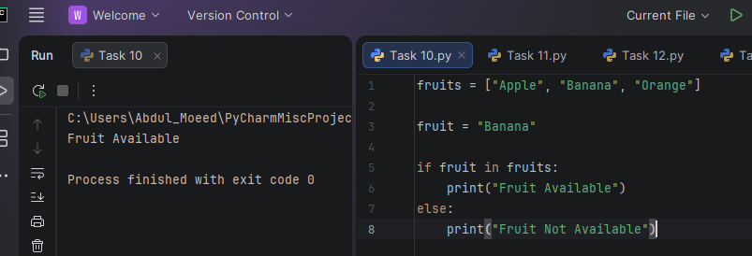
Task 11: Validated password length and numeric character.

Result:
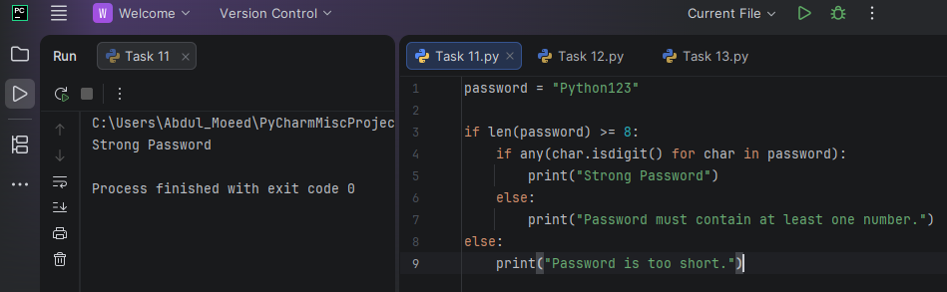

Task 12: Simulated ATM withdrawal using nested conditions.

Result:
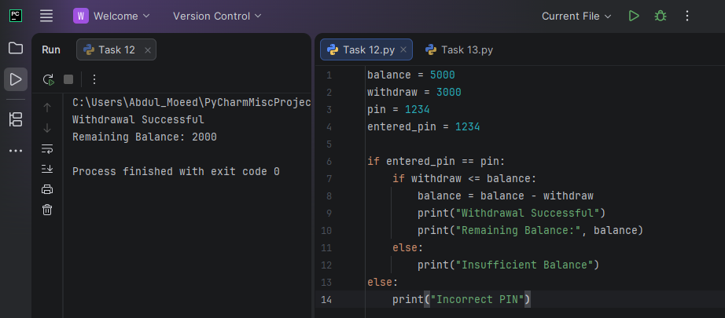

Task 13: Created a simple multi-user login system using if-elif-else.

Result:
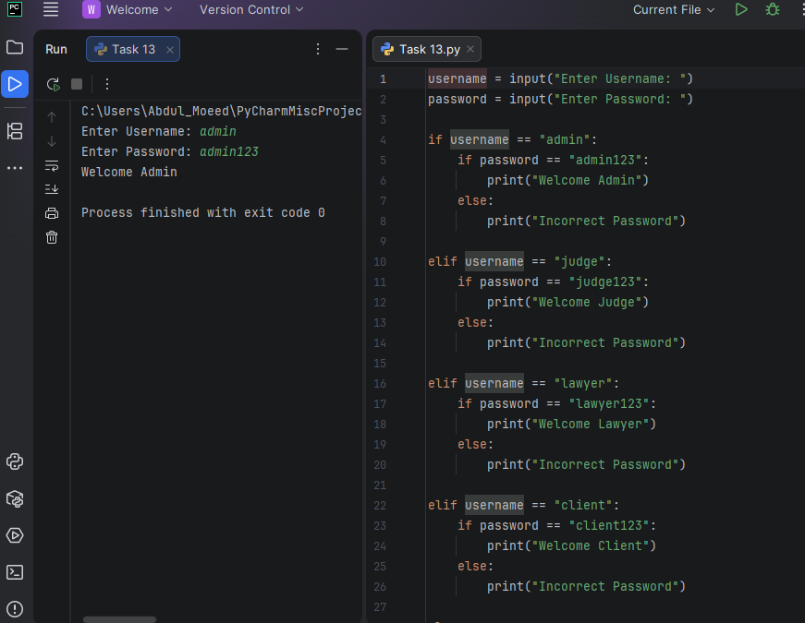

Conclusions:
In this lab, different conditional statements were used to solve basic programming problems. The tasks improved understanding of decision-making in Python and showed how conditions control program flow. These concepts are useful for writing correct and efficient programs.

